UNIWERSYTET W SIEDLCACH

FACULTY OF EXACT AND NATURAL SCIENCES

The Faculty of Informatics

Laboratory report

Selected Programming Paradigms

Book Recommendation

lab 9 and 10

Developed by

Abdullakim Zamirbek uulu

2nd year, Erasmus student computer science and math studies

Course Supervisor

MSc. Maciej Nazarczuk

Siedlce, 2024

Contents
- Formulation of task 2
- Project code 2
- Testing the code. 7
- Conclusions 8

Formulation of Task
Prolog-based book recommendation system. The system should allow users to inquire about books based on specific criteria such as genre, year of release, author, title, country of origin, and readership. Prolog database contains information about various books, including their attributes. Rules to facilitate book recommendations based on user queries, considering different factors.
Requirements:
- Prolog database with facts representing books and their attributes.
- Separate predicates for title, genre, year of release, author, country of origin, and readership.
- Rules for book recommendations based on user queries.
- Demonstrate the system's capability by providing sample queries and expected results.

Facts start here:
% Books database
book('The Catcher in the Rye', 'Fiction', 'J.D. Salinger').
book('Harry Potter and the Philosopher\'s Stone', 'Fantasy', 'J.K. Rowling').
book('The Great Gatsby', 'Fiction', 'F. Scott Fitzgerald').
book('War and Peace', 'Historical Fiction', 'Leo Tolstoy').
book('The Hobbit', 'Fantasy', 'J.R.R. Tolkien').
book('To Kill a Mockingbird', 'Fiction', 'Harper Lee').
book('1984', 'Dystopian', 'George Orwell').
book('Pride and Prejudice', 'Romance', 'Jane Austen').
book('One Hundred Years of Solitude', 'Magical Realism', 'Gabriel Garcia Marquez').
book('The Lord of the Rings', 'Fantasy', 'J.R.R. Tolkien').
book('The Da Vinci Code', 'Mystery', 'Dan Brown').
book('The Hunger Games', 'Science Fiction', 'Suzanne Collins').
book('The Alchemist', 'Fantasy', 'Paulo Coelho').
book('The Shining', 'Horror', 'Stephen King').
book('The Girl with the Dragon Tattoo', 'Mystery', 'Stieg Larsson').
book('The Chronicles of Narnia', 'Fantasy', 'C.S. Lewis').
book('The Road', 'Post-apocalyptic', 'Cormac McCarthy').
book('The Fault in Our Stars', 'Young Adult', 'John Green').
book('The Silence of the Lambs', 'Thriller', 'Thomas Harris').

% Year of release
year('The Catcher in the Rye', 1951).
year('Harry Potter and the Philosopher\'s Stone', 1997).
year('The Great Gatsby', 1925).
year('War and Peace', 1869).
year('The Hobbit', 1937).
year('To Kill a Mockingbird', 1960).
year('1984', 1949).
year('Pride and Prejudice', 1813).
year('One Hundred Years of Solitude', 1967).
year('The Lord of the Rings', 1954).
year('The Da Vinci Code', 2003).
year('The Hunger Games', 2008).
year('The Alchemist', 1988).
year('The Shining', 1977).
year('The Girl with the Dragon Tattoo', 2005).
year('The Chronicles of Narnia', 1950).
year('The Road', 2006).
year('The Fault in Our Stars', 2012).
year('The Silence of the Lambs', 1988).

% Author
author('The Catcher in the Rye', 'J.D. Salinger').
author('Harry Potter and the Philosopher\'s Stone', 'J.K. Rowling').
author('The Great Gatsby', 'F. Scott Fitzgerald').
author('War and Peace', 'Leo Tolstoy').
author('The Hobbit', 'J.R.R. Tolkien').
author('To Kill a Mockingbird', 'Harper Lee').
author('1984', 'George Orwell').
author('Pride and Prejudice', 'Jane Austen').
author('One Hundred Years of Solitude', 'Gabriel Garcia Marquez').
author('The Lord of the Rings', 'J.R.R. Tolkien').
author('The Da Vinci Code', 'Dan Brown').
author('The Hunger Games', 'Suzanne Collins').
author('The Alchemist', 'Paulo Coelho').
author('The Shining', 'Stephen King').
author('The Girl with the Dragon Tattoo', 'Stieg Larsson').
author('The Chronicles of Narnia', 'C.S. Lewis').
author('The Road', 'Cormac McCarthy').
author('The Fault in Our Stars', 'John Green').
author('The Silence of the Lambs', 'Thomas Harris').

% Country of origin
country('The Catcher in the Rye', 'United States').
country('Harry Potter and the Philosopher\'s Stone', 'United Kingdom').
country('The Great Gatsby', 'United States').
country('War and Peace', 'Russia').
country('The Hobbit', 'United Kingdom').
country('To Kill a Mockingbird', 'United States').
country('1984', 'United Kingdom').
country('Pride and Prejudice', 'United Kingdom').
country('One Hundred Years of Solitude', 'Colombia').
country('The Lord of the Rings', 'United Kingdom').
country('The Da Vinci Code', 'United States').
country('The Hunger Games', 'United States').
country('The Alchemist', 'Brazil').
country('The Shining', 'United States').
country('The Girl with the Dragon Tattoo', 'Sweden').
country('The Chronicles of Narnia', 'United Kingdom').
country('The Road', 'United States').
country('The Fault in Our Stars', 'United States').
country('The Silence of the Lambs', 'United States').

% Readers number
readers('The Catcher in the Rye', 50000000).
readers('Harry Potter and the Philosopher\'s Stone', 120000000).
readers('The Great Gatsby', 25000000).
readers('War and Peace', 20000000).
readers('The Hobbit', 100000000).
readers('To Kill a Mockingbird', 40000000).
readers('1984', 60000000).
readers('Pride and Prejudice', 30000000).
readers('One Hundred Years of Solitude', 45000000).
readers('The Lord of the Rings', 150000000).
readers('The Da Vinci Code', 80000000).
readers('The Hunger Games', 65000000).
readers('The Alchemist', 65000000).
readers('The Shining', 30000000).
readers('The Girl with the Dragon Tattoo', 45000000).
readers('The Chronicles of Narnia', 120000000).
readers('The Road', 30000000).
readers('The Fault in Our Stars', 40000000).
readers('The Silence of the Lambs', 30000000).
Rules start here:
% Rule for recommending books of a specific genre
recommend_genre(Genre, Title) :-
book(Title, Genre, _).

% Example query: recommend science fiction books
% ?- recommend_genre('Science Fiction', Title).

% Rule for recommending books by a specific author
recommend_author(Author, Title) :-
book(Title, Author).

% Example query: recommend books by Jane Austen
?- author(Title, 'Jane Austen').

% Rule for recommending books based on readership
recommend_readership(MinReaders, Title) :-
readers(Title, Readers),
Readers >= MinReaders.

% Example query: recommend books with more than 50 million readers
% ?- recommend_readership(50000000, Title).
Testing Phase
Following Query finds list of books with more than 50 million readers
recommend_readership(50000000, Title).
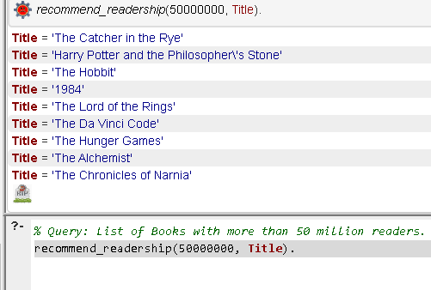

The code bellow recommends science fiction books.
recommend_genre('Science Fiction', Title).
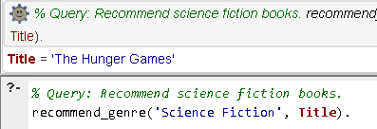

This code will return all books written by Jane Austen.
author(Title, 'Jane Austen').
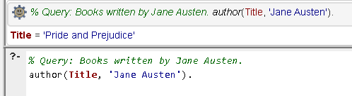

Conclusion:

In this Prolog-based book recommendation system, a database of books has been structured with information about titles, genres, release years, authors, countries of origin, and readership numbers. Users can query the system to find books by a particular author, genre, country of origin, or with a minimum readership. Overall, the Prolog code provides a foundation for a simple yet effective book recommendation system, allowing users to explore and discover books based on their preferences and criteria.

Literature

1. Tchórzewski J., Laboratory exercises in selected programming paradigms declarative , Siedlce, September 2023

